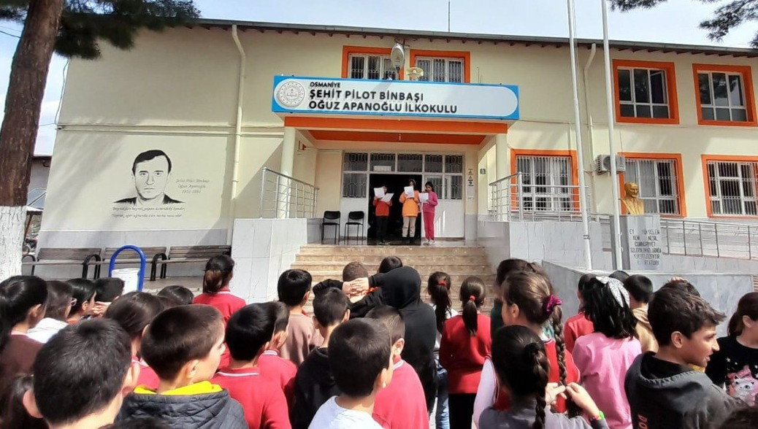

|  |  |  |  |  |  |  |  |
| --- | --- | --- | --- | --- | --- | --- | --- |
| **Hicri Tarih** | **Miladi Tarih** | **İmsak** | **Güneş** | **Öğle** | **İkindi** | **Akşam** | **Yatsı** |
| 1 Ramazan 1446 | 01 Mart 2025 Cumartesi | 5:40 | 6:59 | 12:52 | 16:04 | 18:36 | 19:50 |
| 2 Ramazan 1446 | 02 Mart 2025 Pazar | 5:39 | 6:58 | 12:52 | 16:04 | 18:37 | 19:51 |
| 3 Ramazan 1446 | 03 Mart 2025 Pazartesi | 5:37 | 6:56 | 12:52 | 16:05 | 18:38 | 19:52 |
| 4 Ramazan 1446 | 04 Mart 2025 Salı | 5:36 | 6:55 | 12:52 | 16:05 | 18:38 | 19:53 |
| 5 Ramazan 1446 | 05 Mart 2025 Çarşamba | 5:34 | 6:54 | 12:52 | 16:06 | 18:39 | 19:54 |
| 6 Ramazan 1446 | 06 Mart 2025 Perşembe | 5:33 | 6:52 | 12:51 | 16:06 | 18:40 | 19:55 |
| 7 Ramazan 1446 | 07 Mart 2025 Cuma | 5:32 | 6:51 | 12:51 | 16:07 | 18:41 | 19:56 |
| 8 Ramazan 1446 | 08 Mart 2025 Cumartesi | 5:30 | 6:49 | 12:51 | 16:08 | 18:42 | 19:57 |
| 9 Ramazan 1446 | 09 Mart 2025 Pazar | 5:29 | 6:48 | 12:51 | 16:08 | 18:43 | 19:57 |
| 10 Ramazan 1446 | 10 Mart 2025 Pazartesi | 5:27 | 6:47 | 12:50 | 16:09 | 18:44 | 19:58 |
| 11 Ramazan 1446 | 11 Mart 2025 Salı | 5:26 | 6:45 | 12:50 | 16:09 | 18:45 | 19:59 |
| 12 Ramazan 1446 | 12 Mart 2025 Çarşamba | 5:24 | 6:44 | 12:50 | 16:10 | 18:46 | 20:00 |
| 13 Ramazan 1446 | 13 Mart 2025 Perşembe | 5:23 | 6:42 | 12:50 | 16:10 | 18:47 | 20:01 |
| 14 Ramazan 1446 | 14 Mart 2025 Cuma | 5:21 | 6:41 | 12:49 | 16:10 | 18:48 | 20:02 |
| 15 Ramazan 1446 | 15 Mart 2025 Cumartesi | 5:20 | 6:39 | 12:49 | 16:11 | 18:49 | 20:03 |
| 16 Ramazan 1446 | 16 Mart 2025 Pazar | 5:18 | 6:38 | 12:49 | 16:11 | 18:50 | 20:04 |
| 17 Ramazan 1446 | 17 Mart 2025 Pazartesi | 5:17 | 6:36 | 12:48 | 16:12 | 18:51 | 20:05 |
| 18 Ramazan 1446 | 18 Mart 2025 Salı | 5:15 | 6:35 | 12:48 | 16:12 | 18:52 | 20:06 |
| 19 Ramazan 1446 | 19 Mart 2025 Çarşamba | 5:13 | 6:33 | 12:48 | 16:13 | 18:52 | 20:07 |
| 20 Ramazan 1446 | 20 Mart 2025 Perşembe | 5:12 | 6:32 | 12:48 | 16:13 | 18:53 | 20:08 |
| 21 Ramazan 1446 | 21 Mart 2025 Cuma | 5:10 | 6:30 | 12:47 | 16:13 | 18:54 | 20:09 |
| 22 Ramazan 1446 | 22 Mart 2025 Cumartesi | 5:09 | 6:29 | 12:47 | 16:14 | 18:55 | 20:10 |
| 23 Ramazan 1446 | 23 Mart 2025 Pazar | 5:07 | 6:27 | 12:47 | 16:14 | 18:56 | 20:11 |
| 24 Ramazan 1446 | 24 Mart 2025 Pazartesi | 5:05 | 6:26 | 12:46 | 16:14 | 18:57 | 20:12 |
| 25 Ramazan 1446 | 25 Mart 2025 Salı | 5:04 | 6:24 | 12:46 | 16:15 | 18:58 | 20:13 |
| 26 Ramazan 1446 | 26 Mart 2025 Çarşamba | 5:02 | 6:23 | 12:46 | 16:15 | 18:59 | 20:14 |
| **KADİR GECESİ** | | | | | | | |
| 27 Ramazan 1446 | 27 Mart 2025 Perşembe | 5:01 | 6:21 | 12:45 | 16:15 | 19:00 | 20:15 |
| 28 Ramazan 1446 | 28 Mart 2025 Cuma | 4:59 | 6:20 | 12:45 | 16:16 | 19:00 | 20:16 |
| 29 Ramazan 1446 | 29 Mart 2025 Cumartesi | 4:57 | 6:18 | 12:45 | 16:16 | 19:01 | 20:17 |
| **30 Mart 2025 Pazar Ramazan Bayramının 1.Günüdür** | | | | | | | |
| **Bayram Namazı 06:53** | | | | | | | |
| **Sadaka-I Fıtır Miktarı :180 TL’dir** | | | | | | | |